1. Which are the top three variables in your model which contribute most towards the probability of a lead getting converted?

Ans:

* Lead Source
* Total Time Spent on Website
* Last Notable Activity
* What is your current occupation

1. What are the top 3 categorical/dummy variables in the model which should be focused the most on in order to increase the probability of lead conversion?

Ans:

* Lead Source_Welingak Website
* Source_Reference
* What is your current occupation_Working Professional
* Last Notable Activity_Had a Phone Conversation

1. X Education has a period of 2 months every year during which they hire some interns. The sales team, in particular, has around 10 interns allotted to them. So during this phase, they wish to make the lead conversion more aggressive. So they want almost all of the potential leads (i.e. the customers who have been predicted as 1 by the model) to be converted and hence, want to make phone calls to as much of such people as possible. Suggest a good strategy they should employ at this stage.

Ans:

Sensitivity in our model is the ratio of correctly predicted actual conversions to the total number of actual conversions, while specificity is the ratio of correctly predicted actual non-conversions to the total number of actual non-conversions. Adjusting the conversion probability cutoff threshold impacts these values inversely. A graph illustrates that lower thresholds increase sensitivity but decrease specificity, and higher thresholds exhibit the opposite trend.

In pursuit of an aggressive lead conversion approach over the next two months, X Education, with increased manpower and interns, aims to identify almost all potential leads. Opting for a lower conversion probability threshold ensures high sensitivity, correctly identifying most potential conversions. Despite potential misclassifications of non-conversions, the strategy aligns with the company's goal. It's crucial to focus efforts on leads with low conversion probability to enhance the overall conversion rate.

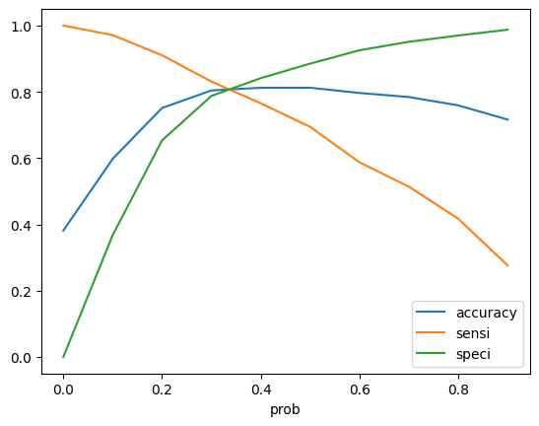

1. Similarly, at times, the company reaches its target for a quarter before the deadline. During this time, the company wants the sales team to focus on some new work as well. So during this time, the company’s aim is to not make phone calls unless it’s extremely necessary, i.e. they want to minimize the rate of useless phone calls. Suggest a strategy they should employ at this stage.

Ans:

In the quarter preceding the deadline, the company, facing time constraints, must prioritize hot leads with the highest conversion rates. By focusing on leads with a lead score exceeding 80%, the company can efficiently target its efforts, avoiding unnecessary calls.

In a similar context to the previous question, a high specificity indicates that our model accurately identifies leads unlikely to convert, but at the expense of potentially losing some risky, low-conversion-rate leads to competitors. As X Education has already achieved its quarterly target and aims to minimize unnecessary phone calls, opting for a higher conversion probability threshold is prudent.This higher threshold ensures exceptional specificity, meaning that leads teetering on the probability threshold of conversion are excluded. Consequently, agents can avoid making unnecessary calls and redirect their efforts toward new initiatives.